We follow a structured dataset versioning approach:
- Raw Data Storage
- All incoming raw datasets are stored in data/raw/
- Example: data/raw/bank_churn_api_raw.csv, data/raw/bank_churn_loc_raw.csv
- Processed Data
- Preprocessed data is stored in data/processed/
- Version-controlled via DVC, allowing rollbacks to previous states
- Transformed Data
- Feature-engineered datasets are stored in data/transformed/
- Used for training machine learning models

dvc add CustomerChurn/data/processed
dvc add CustomerChurn/data/transformed
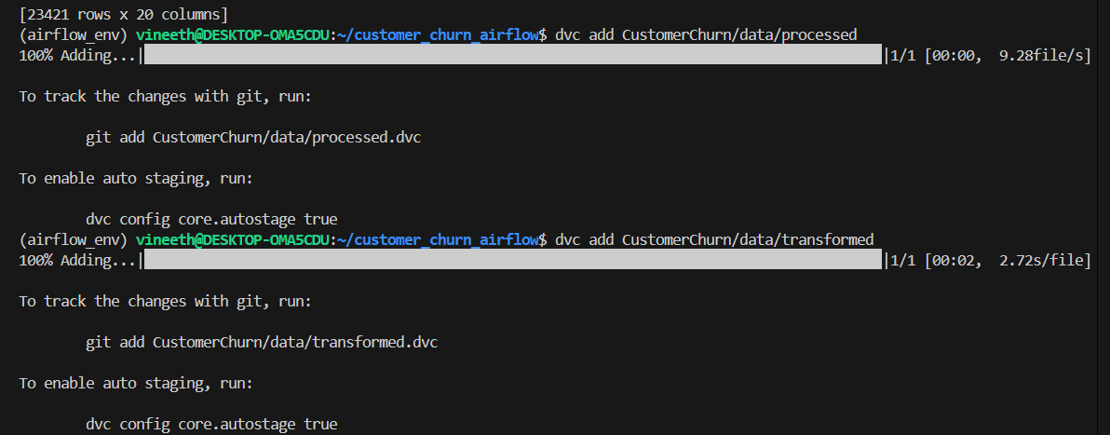

dvc push
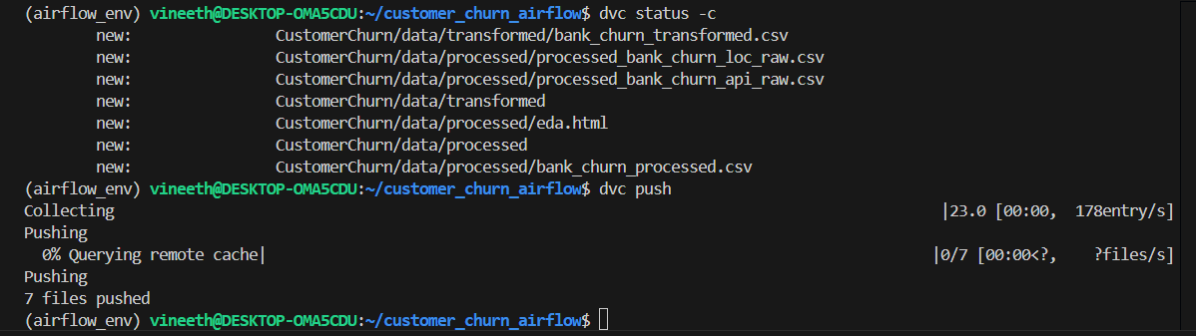

Versioned files configured to be stored in google drive. Below is an example of bank_churn_processed.csv file saved in google drive using data version control
